SIT314 Week 10 Technical Task Report

# 1. Objective

Deploy a basic Node.js web application using Docker on an AWS EC2 instance, and ensure it is accessible via the browser.

# 2. Process Overview

## a. Install Docker on EC2 Instance

• Command: sudo apt install docker.io  
• Verified Docker installed and services started.

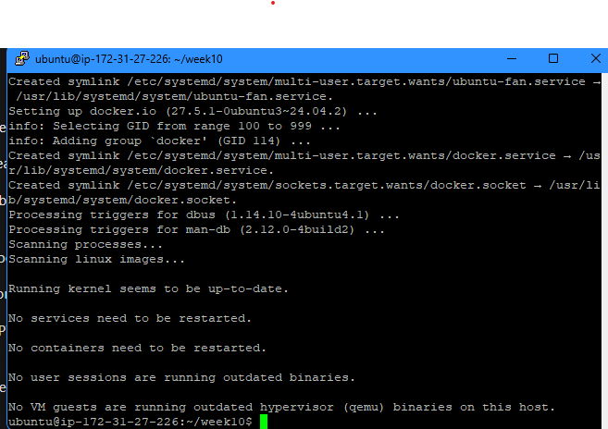

## b. Build Docker Image from Dockerfile

• Dockerfile was created alongside server.js and package.json.  
• Command used:  
 sudo docker build -t sit314 .

## c. Run Docker Container on Port 3000

• Ran container using:  
 sudo docker run -p 3000:3000 sit314  
• Confirmed port binding using docker container ls.

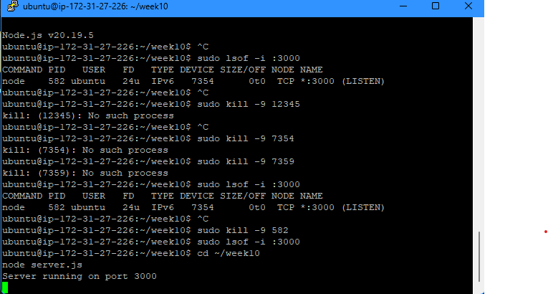

## d. Error Fix: Port 3000 Already in Use

• Identified using: lsof -i :3000  
• Killed the process using:  
 sudo kill -9 <PID>  
• Re-ran node server.js successfully.

# 3. Final Outcome

• Navigated to http://<public-ip>:3000 in browser.  
• Webpage shows:  
 Hello World from EC2!

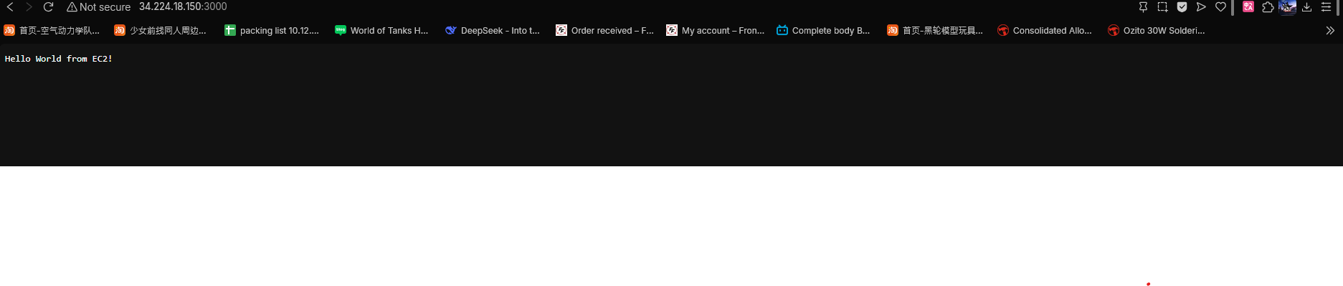

# Conclusion

Successfully deployed a Dockerized Node.js app on AWS EC2 and resolved server binding issues. The server is accessible via the browser on port 3000.